CS 255 System Design Document Template

This template lays out all the different sections that you need to complete for Project Two. Each section has guidance to prompt your thinking. You will need to continually reference the interview transcript as you work to make sure that you are addressing your client’s needs. There is no required length for the final document. Instead, the goal is to complete each section based on what your client’s needs are. Remove this note when you are finished and replace all bracketed text with the relevant information.

UML Diagrams

UML Use Case Diagram
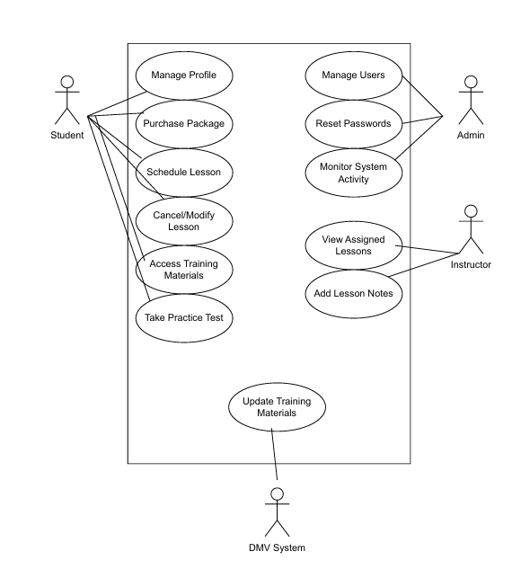

UML Activity Diagrams

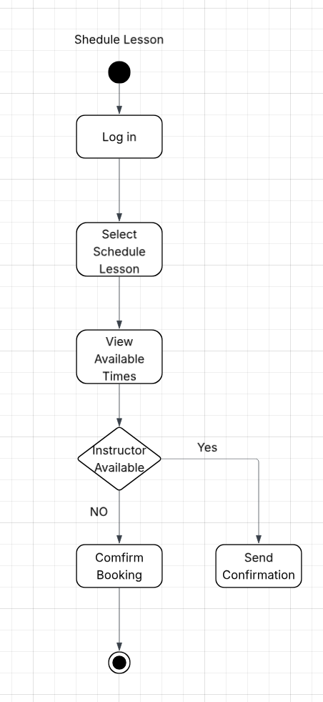
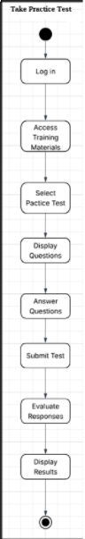

UML Sequence Diagram
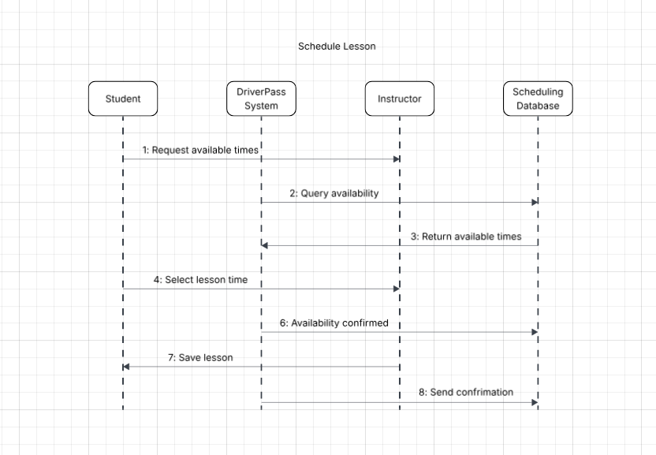

UML Class Diagram

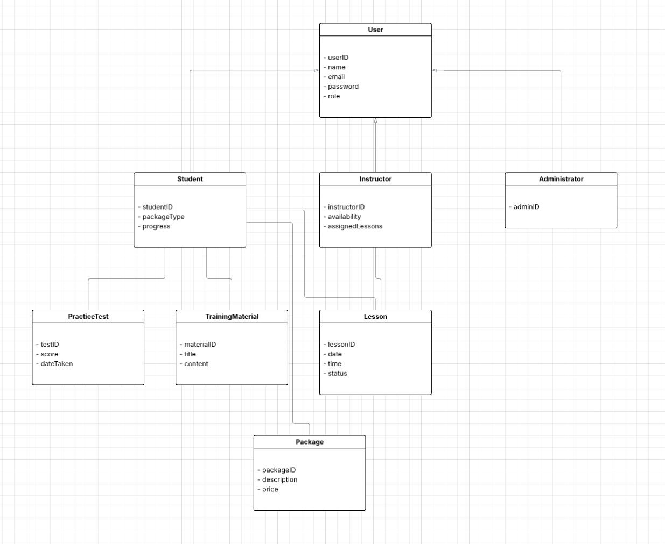

Technical Requirements
The DriverPass system needs to run as a secure web application that works on modern desktops and mobile browsers. It requires a reliable server environment, a relational database to store users and scheduling information, and HTTPS to protect all data. The system must support user login, role-based access for students, instructors, and admins, and safe communication with third-party payment processors. Regular backups, basic system monitoring, and routine updates are needed to keep the system running smoothly. The system should handle multiple users at once without slowing down and allow administrators to manage users and content through built-in tools.

